A New Province
Star of the Sea
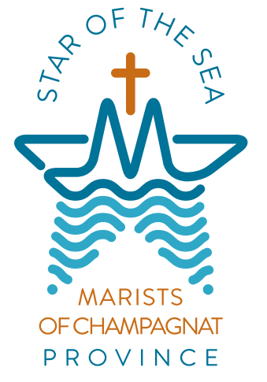

On 8 December 2022, the Feast of the Immaculate Conception of the blessed virgin Mary, the Star of the Sea Province was inaugurated by the Superior General of the Marist Brothers. A Province is an administrative unit within the Institute of the Marist Brothers.

The Brothers, communities and ministries that constitute the Star of the Sea Province within the Institute will be those in New Zealand, Australia, Cambodia, Fiji, Kiribati, New Caledonia, Papua New Guinea, Samoa, Solomon Islands, Timor Leste and Vanuatu.

The Star of the Sea Province is of course much more than an administrative and governance structure. It is also a community for all Champagnat Marists. The familial relations that are necessary cannot be established quickly. They will develop over time as the Brothers and Marists of Champagnat become familiar with one another. Fortunately, we are not starting from scratch; there are already solid foundations for growth in this area. Working relationships and friendships have been formed in previous decades. Over and above cultural and historical differences our faith, Founder and our shared Marist story will bring a sense of common purpose and vision.

The Logo
The Star: is subtle and formed from the apex of the cross, to the left and right extremities and to the bottom of the waves.

The Sea: the wave shape, with the multiples and different sizes representing the diversity of the Star of the Sea Province, composed of quite different nations.

Marist: the M is obvious in the centre of the design and acknowledges the centrality of Mary to our lives as Marists of Champagnat.

The Boat: upon the waves, is a traditional image for the Church, the barque of Christ, referring as it does to the Apostles in the boat with Jesus. We are navigating and travelling together as a community and family.

A Prayer of Blessing for the New School Year

May God's Holy Spirit bless all at this school.

May the Spirit of the North, the spirit of the Pacific,
surround us with love.
As the sun gives warmth to the earth,
may the Holy Spirit encourage us to share
God’s love with one another.

May the Spirit of the South, the spirit of the Antarctic,
give us courage.
As we brace for cold winds,
may the Holy Spirit give us strength to face
the challenges which we will encounter.

May the Spirit of the East, the spirit of sunrise,
give us wisdom and understanding,
may we never be afraid to start afresh.

May the Spirit of the West, the spirit of sunset,
give us knowledge and good judgement,
may your Word guide the path which we walk.

May the Holy Spirit of God
who is present in this school and in each of us,
surround us all as we begin
this new school year with love and peace. Amen.

Mary, Star of the Sea – Pray for us.
Champagnat Marist Spirituality and Charism:
God’s Presence and Love Trust in God Love of Jesus and His Gospel
Presence Simplicity Family Spirit Love of Work
In the Way of Mary

